Name : Ankith M Mahalathkar (1BM25CS414)

Aim:
To configure and verify DHCP for multiple LANs using the given Cisco Packet Tracer topology, with a router acting as a DHCP relay agent and a centralized server providing IP addresses to clients in different networks.

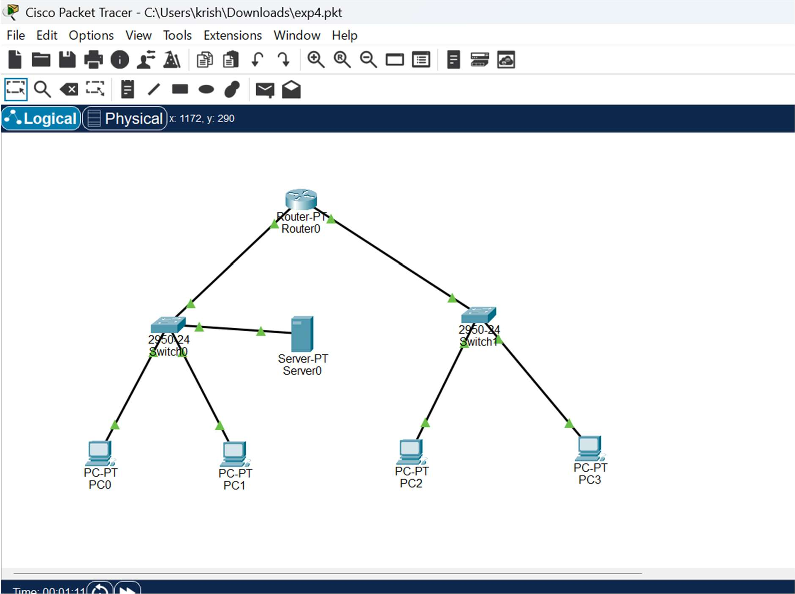

Devices required
Use the same devices shown in your topology:
- 1 Router-PT (Router0)
- 2 Cisco 2950-24 switches (Switch0 and Switch1)
- 1 Server-PT (Server0)
- 4 PCs (PC0, PC1, PC2 and PC3)
- Copper straight-through cables

Step-by-step procedure
Step 1: Create the topology
- Open Cisco Packet Tracer.

Step 2: Configure Router0 interfaces
Click Router0 → CLI, press Enter and enter the following commands:
enable
configure terminal

interface fastEthernet 0/0
ip address 10.0.0.1 255.0.0.0 no shutdown exit

interface fastEthernet 1/0
ip address 20.0.0.1 255.0.0.0 no shutdown exit

These commands assign IP addresses to the two LAN-facing interfaces and enable them.

Step 3: Configure the DHCP relay agent On Router0, enter:

configure terminal interface fastEthernet 1/0 ip helper-address 10.0.0.2 exit end
write memory

Explanation:
- interface fastEthernet 1/0 selects the interface connected to Switch1 and the remote clients.
- ip helper-address 10.0.0.2 forwards DHCP requests to Server0.
- write memory saves the router configuration.

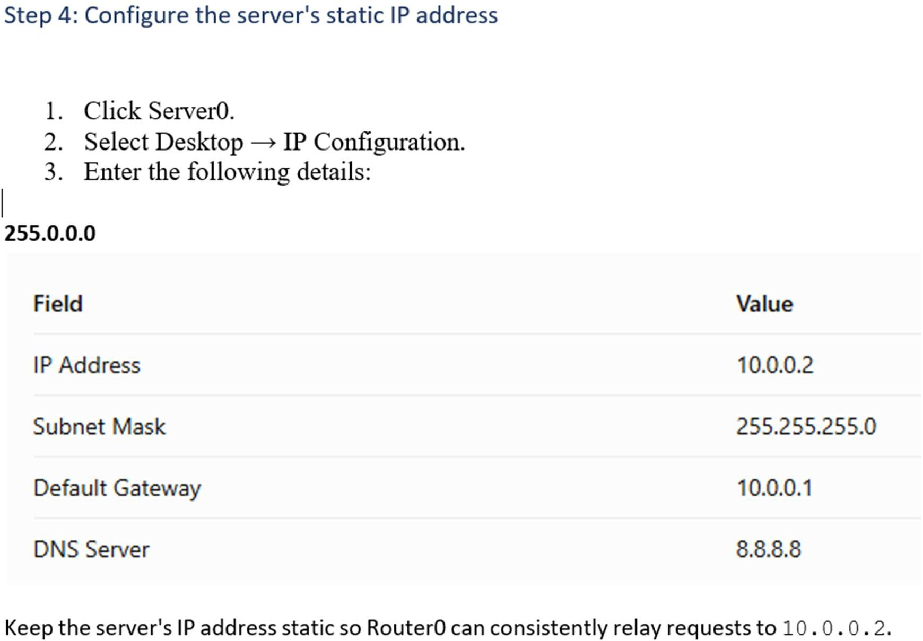

Step 5: Configure DHCP Pool 1 for Switch0 LAN
- Click Server0 → Services → DHCP.
- Set the DHCP service to On.
- Enter the following configuration:

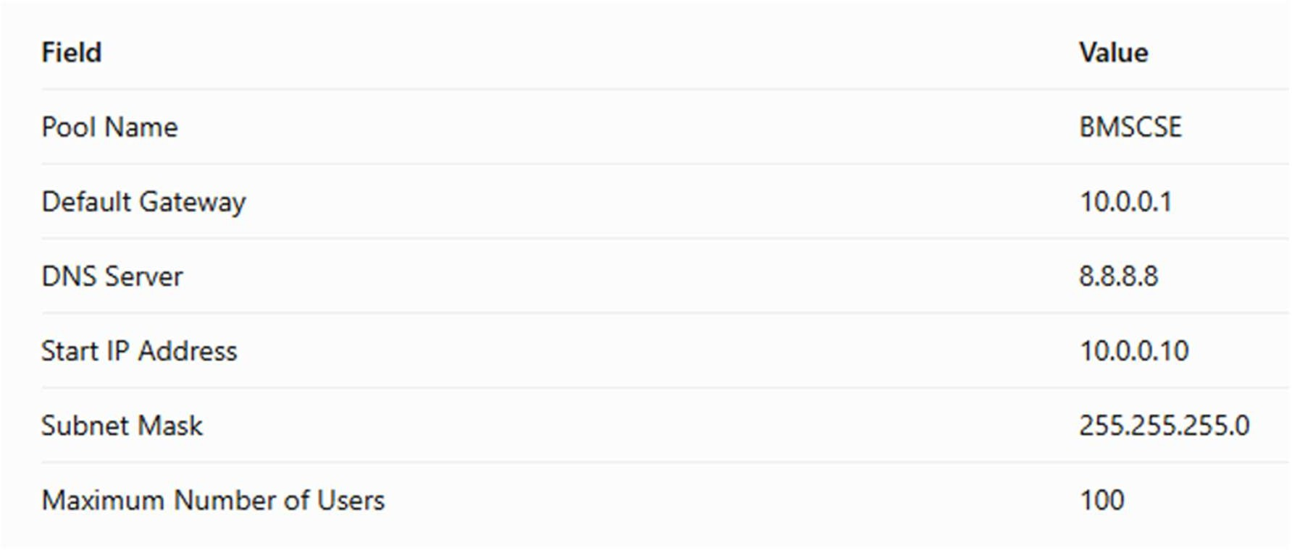

Click Add or Save, as applicable in your Packet Tracer version. This pool provides addresses to PC0 and PC1 on the first LAN.
Step 6: Configure DHCP Pool 2 for Switch1 LAN
On the same Services → DHCP page, configure the second pool:

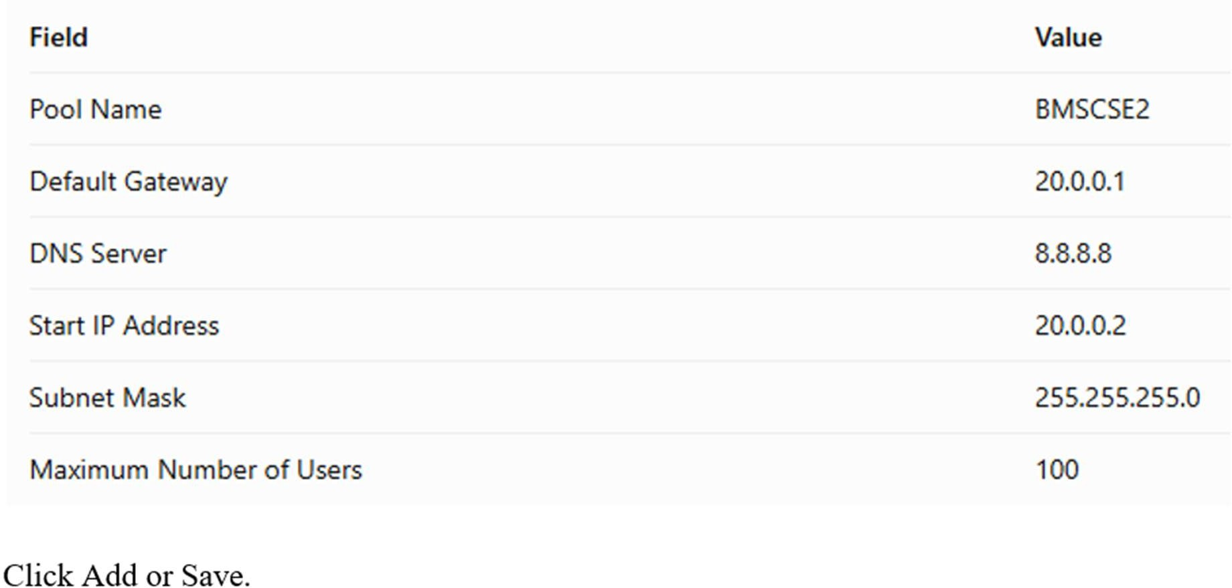

- Place one Router-PT, two 2950-24 switches, one Server-PT and four PCs.
- Rename the devices as shown in your diagram: Router0, Switch0, Switch1, Server0, PC0, PC1, PC2 and PC3.
- Connect the devices using copper straight-through cables.
This pool provides addresses to PC2 and PC3. The server chooses the appropriate subnet based on the DHCP request and relay information received from Router0.

Step 7: Configure all PCs to use DHCP
Perform these steps for PC0, PC1, PC2 and PC3:
- Click the PC.
- Select Desktop → IP Configuration.

Click DHCP.
- Wait for the address configuration to complete.
- Verify the assigned IP address, subnet mask and default gateway. Expected address ranges:
  - PC0 and PC1: 10.0.0.10 onward, gateway 10.0.0.1.
  - PC2 and PC3: 20.0.0.2 onward, gateway 20.0.0.1.
The exact addresses assigned may vary depending on the order in which clients request leases.

Verification and testing
Test 1: Verify the IP addresses
On each PC, open Desktop → Command Prompt and enter:

Ipconfig
Check that the IP address and default gateway correspond to the correct LAN.

Test 2: Verify connectivity from PC0 and PC1 On PC0, enter:

ping 10.0.0.1
ping 10.0.0.2

Both should succeed when the interfaces and server are configured correctly.

Test 3: Verify connectivity from PC2 and PC3 On PC2, enter:

ping 20.0.0.1
ping 10.0.0.2
The first ping tests the local gateway; the second tests connectivity to the DHCP server across Router0.

Test 4: Verify the DHCP service
Open Server0 → Services → DHCP and confirm that both pools are configured. On Router0, enter:

show ip interface brief show running-config

Confirm that both interfaces are up and that ip helper-address 10.0.0.2 is configured under FastEthernet1/0.
Because Server0 is the DHCP server, use its DHCP service page to inspect the pools; the router's show ip dhcp binding command will not show leases issued by Server0.
Test 5: Observe DHCP in Simulation mode
- Switch Packet Tracer from Realtime to Simulation mode.
- Use Edit Filters to display DHCP and ARP packets.
- Renew a PC's DHCP configuration or toggle the PC's DHCP selection.
- Observe the DHCP Discover, Offer, Request and Acknowledgment sequence. For PC2 or PC3, observe the relay process between Router0 and Server0.

